MG NEW YORK – OVERVIEW

OVERVIEW

Businesses
There are 3 main businesses controlled from NY;

Copper Concentrates
Business headed up by Phil Bacon based in NY.

The team of traders purchase copper concentrate (copper ore direct from mines – includes Gold & Silver content) which is a black powder with impurities and varying metal content, and ship to smelters to whom they sell the concentrate. (Details included on separate note)

Metals Trading
Business headed up by Jo Robertson in NY

The team of traders provide agency services to MCC for Aluminium, Zinc & Copper in New York. They also have an agency business (this used to be principal business before the trading incident at the end of 1999) for primary Aluminium trading out of Chicago & Montreal. The new office in Montreal is to head this up following a 4 person purchase from Barclays, however logistics support is currently in New York & Montreal. Aluminium scrap is based in Chicago and Copper scrap based in St Louis. (Details included on separate note).

Financial Services
Business headed up by Craig Young in London & TJ Pimpinelli in NY.

There are three main sections;
- FCM (futures clearing member) where MGL Inc is registered as a CTA (commodities trade advisor) with the CFTC and NFA – they act as clearing brokers on Comex and the NYMEX (however there is no activity at present on the NYMEX). 98% of business is with MG plc Group companies.
- Introducing broker for LME OTC trades for North American customers of MGL

- Offshore Fund – managed by Craig Young in London
(Details included in separate note)

Organisation

Separate business notes include organisation charts for each business unit for trading through contract admin (includes setttlements).

IMPORTANT NOTE; MG Nth America – forms part of the original MG group and is not part of MG PLC. MG NY – refers to any MG business included in the PLC group.

SUPPORT ORGANISATION

They are all supported through NY by a centralised services group headed up by Marcelo Parra (see below).

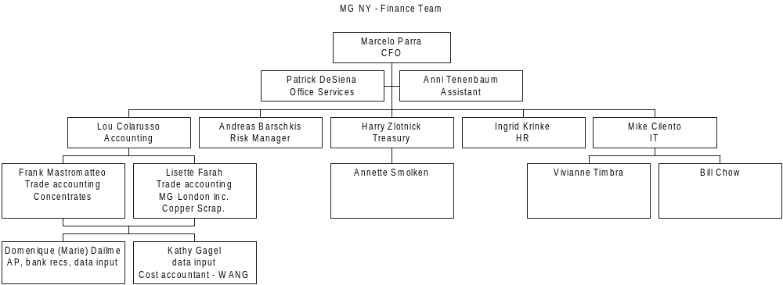

Also, please note;

- Helge Morel is a retired MG employee who works as a contractor part time on credit reporting directly to Marcello
- Tax & Legal services provided by teams from MG Nth America based in same office.
- MG Nth America used to provide accounting for Henry Bath Inc – now passed onto local outsourcer and not controlled by MG NY.

A separate note gives details of the support and controls offered in terms of credit control, cash management, accounting and general controls.

Specific Points for consideration

- Remote offices are highly decentralised
- Separation from MG NA has not yet been finalised
- Segregation of duties between trading, logistics and settlements is generally unclear (largely due to a culture of using the contract administration area as a training ground for future traders)
- Each of the businesses and locations use different systems to manage their business.

